**BIT302 SOFTWARE ENGINEERING**

**Assignment 1**

HELP COVID-19 Testing Information System (CTIS) Website – Requirements Specification Document



**Team Leader**

I Made Siva Aditya Surya / E1800176

[mdsivaaditya@gmail.com](mailto:mdsivaaditya@gmail.com)

**Member**

Ida Bagus Gede Awidya Andika / E1800182

[awidyaandika@gmail.com](mailto:awidyaandika@gmail.com)

2021

Table of Contents

**1.** **Functional and Non-functional Requirements** 1

**2.** **Use Case Diagram** 3

**3.** **Analysis Class Diagram** 4

**4.** **Expanded Use Cases** 5

4.1. Log In 5

4.2. View Test Kit 5

4.3. Manage Test Kit 6

4.4. View Test Centre 7

4.5. Register Test Centre 7

4.6. View Test Centre Officer 8

4.7. Record Tester 9

4.8. Record Officer 10

4.9. Record New Test 11

4.10. Update Test Result 11

4.11. Generate Test Report 12

4.12. View Testing History 13

4.13. Log Out 13

**5.** **System Sequence Diagrams + Contracts** 15

5.1. Log In 15

5.2. View Test Kit 16

5.3. Manage Test Kit 17

5.4. View Test Centre 18

5.5. Register Test Centre 19

5.6. View Test Centre Officer 20

5.7. Record Tester 21

5.8. Record Officer 22

5.9. Record New Test 24

5.10. Update Test Result 26

5.11. Generate Test Report 27

5.12. View Testing History 28

5.13. Log Out 29

1. **Functional and Non-functional Requirements**

**Functional Requirements**

**Patient Requirements:**

1. A menu to login to the system
2. Username and password verification in login menu
3. Home page menu after patient successfully login to system
4. A button in home page menu to navigate to view testing history menu
5. View testing history menu that shows the patient’s Covid-19 test data and result in chronological order
6. A button to log out from the system

**Test Centre Officer Requirements:**

1. A menu to login to the system
2. Username and password verification in login menu
3. Home page menu after test centre officer successfully login to system
4. A button in home page menu to navigate to generate test report menu
5. Generate test report menu shows a list of all test that have been administered in the test centre that the officer is employed at are shown in chronological order

**Test Centre Tester Requirements:**

1. A menu to login to the system
2. Username and password verification in login menu
3. Test Centre Tester dashboard after successfully login to system
4. A sidebar in dashboard to navigate to record new test menu, update test result menu, and generate test report
5. A form in record new test menu with appropriate label and column to fill out patient data, patient type, and symptoms and a button to record the data
6. Update test result menu shows a list of test data in chronological order with a button to edit test result, the button will navigate to update test result page with appropriate form to fill out the result data and a button to update the test result
7. Generate test report menu shows a list of all test that have been administered in the test centre that the officer is employed at are shown in chronological order

**Test Centre Manager Requirements:**

1. A menu to login to the system
2. Username and password verification in login menu
3. Test Centre Manager dashboard after successfully login to system
4. A sidebar in dashboard to navigate to view test kit menu, manage test kit stock menu, register test centre menu, view test centre menu, view test centre officer menu, record test centre officer, record tester menu, generate test report
5. View test kit menu shows a list of all test kit that the test centre has and its stock
6. Manage test kit menu that includes a list of all test kit available with its stock, a button to input new test kit, and a button to update test kit details
7. Register test centre menu that includes a form with appropriate label and column to fill out test centre data and a button to register the test centre
8. View test centre menu shows a list of all recorded test centre data in database
9. View test centre officer menu shows a list of all test centre officer (regardless of position) that is employed in the manager’s test centre
10. Record test centre officer menu that includes a form with appropriate label and column to fill out test centre officer data, username verification, and a button to record the officer data to database
11. Record tester menu that includes a list of test centre officer (with the specific position of ‘officer’) and a button to update the officer position to tester
12. Generate test report menu shows a list of all test that have been administered in the test centre that the officer is employed at are shown in chronological order

**Non-functional Requirements**

1. Correctness – all the information that is recorded to the system and provided by the system must be accurate, complete, and up-to-date. To support this requirement, the system must have a data verification every time a data is about to be recorded to the database.
2. Efficiency – the system should be lightweight and does not require extensive amount of hardware resources to perform a function.
3. Privacy of information – personal patient and officer data that is stored in the database must be properly consent and regulated.
4. Integrity – the system must control unauthorized person from accessing and changing the data. The only one who can record and update test centre officer data and position is the manager. The only who can record and update patient’s test data and test result is the test centre tester.
5. Usability – the system should be easy to learn, understand, and operate all the features. To support this requirement, a good design for the website with appropriate icon for buttons and menu should be implemented.
6. Reliability – the system should perform all its functions as intended without failure.
7. 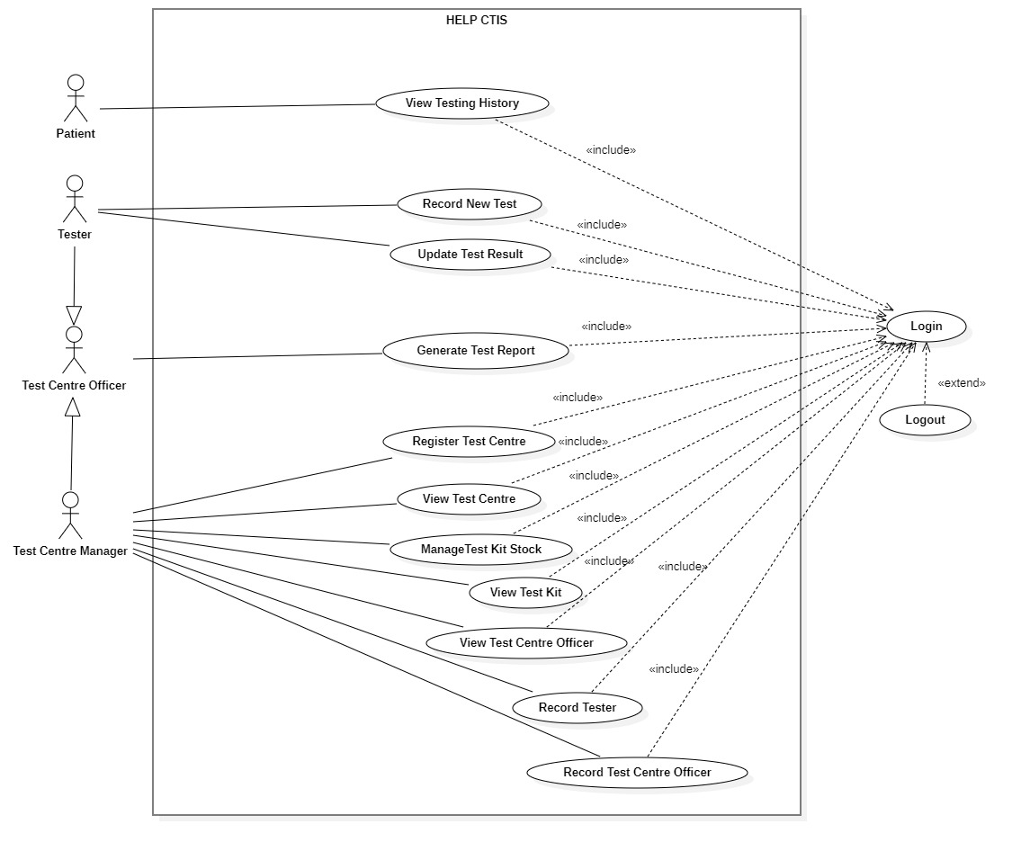**Use Case Diagram**

Figure . Use Case Diagram

1. **Analysis Class Diagram**

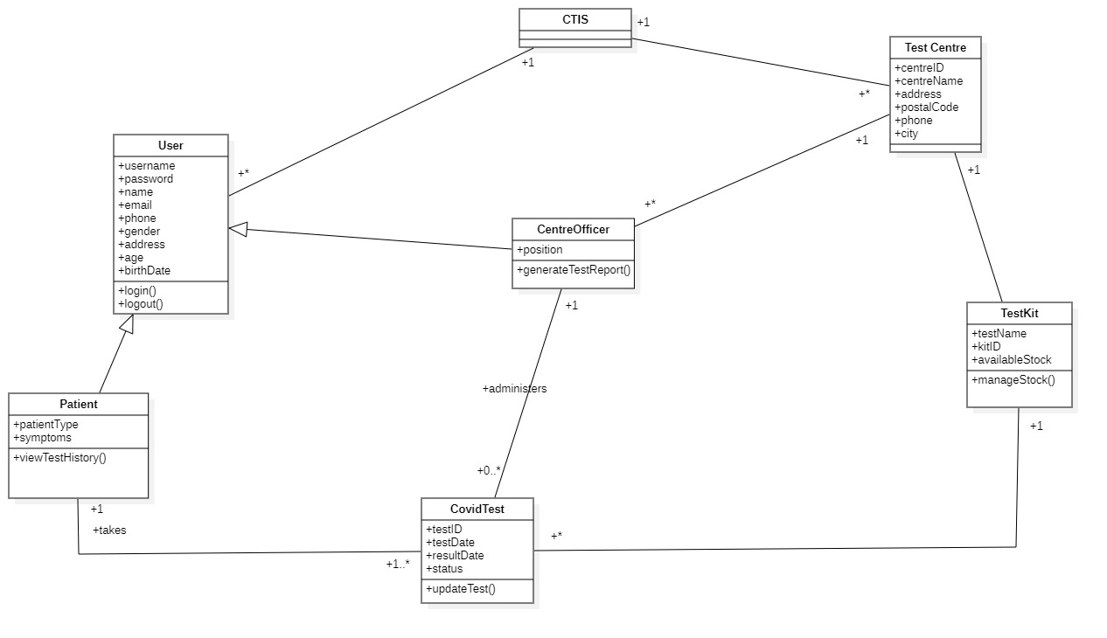

Figure . Class Diagram

1. **Expanded Use Cases**
   1. Log In

|  |  |
| --- | --- |
| Use Case | Log in |
| Goal in Context | Allow Test Centre Officer to access the website home page |
| Primary Actor  Secondary Actor | Test Centre Officer and Patient  **-** |
| Typical Course of Events | |
| Actor Actions | **System Response** |
| 1. Process begins when the Test Centre Officer/Patient input their username and password and click the login button | 2. System will verify the input data, whether it matches the data in database or not |
|  | 3. System will navigate the user to their homepage/password |
| Alternative Course | |
| 1a: If Test Centre Officer or Patient inputs incorrect username or password, then the system will display a warning notification that includes an instruction to try log in again | |

* 1. View Test Kit

|  |  |
| --- | --- |
| Use Case | View identity |
| Goal in Context | Allow Test Centre Manager to view a list of test kit data |
| Primary Actor  Secondary Actor | Test Centre Manager  **-** |
| Typical Course of Events | |
| Actor Actions | **System Response** |
| 1. Process begins after Test Centre Manager has successfully login to system | 1. System will navigate Test Centre Manager to their dashboard |
| 1. Test Centre Manager clicks test kit menu | 1. System displays a list of test kit data |
| Alternative Course | |
| - | |

* 1. Manage Test Kit

|  |  |
| --- | --- |
| Use Case | View identity |
| Goal in Context | Allow Test Centre Manager to add test kit or update test kit stock |
| Primary Actor  Secondary Actor | Test Centre Manager  **-** |
| Typical Course of Events | |
| Actor Actions | **System Response** |
| 1. Process begins after Test Centre Manager has successfully login to system | 1. System will navigate Test Centre Manager to their dashboard |
| 1. Test Centre Manager clicks test kit menu | 1. System will display a list of test kit data |
| 1. Test Centre Manager clicks add test kit | 1. System will navigate Test Centre Manager to add test kit page and display test kit data form |
| 1. Test Centre Manager fills in the data for the name of the test kit and the amount of stock on the form provided, then clicks the submit button | 1. System will store the data that has been entered by the Test Centre Manager into the database then Test Centre Manager will be directed to the test kit page and a message that notifies success in adding the test kit is displayed |
| Alternative Course | |
| 5a: if test kit is already recorded in the database, Test Centre Manager will be able to update the stock amount of the available test kit | |

* 1. View Test Centre

|  |  |
| --- | --- |
| Use Case | View identity |
| Goal in Context | Allow Test Centre Manager to view the list of test centre |
| Primary Actor  Secondary Actor | Test Centre Manager  **-** |
| Typical Course of Events | |
| Actor Actions | **System Response** |
| 1. Process begins after Test Centre Manager has successfully login to system | 1. System will navigate Test Centre Manager to their dashboard |
| 1. Test Centre Manager clicks the test centre menu | 1. System will display a list of test centre data |
| Alternative Course | |
| - | |

* 1. Register Test Centre

|  |  |
| --- | --- |
| Use Case | View identity |
| Goal in Context | Allow Test Centre Manager to register test centre |
| Primary Actor  Secondary Actor | Test Centre Manager  **-** |
| Typical Course of Events | |
| Actor Actions | **System Response** |
| 1. Process begins after Test Centre Manager has successfully login to system | 1. System will navigate Test Centre Manager to their dashboard |
| 1. Test Centre Manager clicks test centre menu | 1. System will display a list of test centre data |
| 1. Test Centre Manager clicks add test centre button | 1. System will navigate to Test Centre Manager to add test centre page and displays test centre data form |
| 1. Test Centre Manager fills in the name and address of the test centre on the form and then clicks the submit button | 1. System will store the data that has been inputted by the Test Centre Manager into the database, then Test Centre Manager will be directed to the test centre page and a message that notifies success in registering the test centre is displayed |
| Alternative Course | |
| - | |

* 1. View Test Centre Officer

|  |  |
| --- | --- |
| Use Case | View identity |
| Goal in Context | Allow Test Centre Manager to view a list of test centre officer data |
| Primary Actor  Secondary Actor | Test Centre Manager  **-** |
| Typical Course of Events | |
| Actor Actions | **System Response** |
| 1. Process begins after Test Centre Manager has successfully login to system | 1. System will navigate Test Centre Manager to their dashboard |
| 1. Test Centre Manager clicks test centre officer menu | 1. System will display a list of test centre officer data |
| Alternative Course | |
| - | |

* 1. Record Tester

|  |  |
| --- | --- |
| Use Case | View identity |
| Goal in Context | Allow Test Centre Manager to record tester |
| Primary Actor  Secondary Actor | Test Centre Manager  **-** |
| Typical Course of Events | |
| Actor Actions | **System Response** |
| 1. Process begins after Test Centre Manager successfully login to system | 1. System will navigate Test Centre Manager to their dashboard |
| 1. Test Centre Manager clicks test centre officer menu | 1. System will display a list of test centre data |
| 1. Test Centre Manager clicks edit button on the test centre officer whose position is going to be changed to tester | 1. System will navigate Test Centre to the test centre officer edit page and display the test centre officer data form |
| 1. Test Centre Manager changes the position of test centre officer from “officer” to “tester” | 1. System will store the data that has been entered by the Test Centre Manager into the database then the Test Centre Manager will be navigated to the test centre officer page and a message appears that notifies success in recording tester is displayed |
| Alternative Course | |
| - | |

* 1. Record Officer

|  |  |
| --- | --- |
| Use Case | View identity |
| Goal in Context | Allow Test Centre Manager to record test centre officer |
| Primary Actor  Secondary Actor | Test Centre Manager  Test Centre Officer |
| Typical Course of Events | |
| Actor Actions | **System Response** |
| 1. Process begins after Test Centre Manager successfully login to system | 1. System will navigate Test Centre Manager to their dashboard |
| 1. Test Centre Manager clicks test centre officer menu | 1. System will display a list of test centre officer data |
| 1. Test Centre Manager clicks add test centre officer button | 1. System will navigate Test Centre Manager to add test centre officer page and display test centre officer data form |
| 1. Test Centre Manager fills in the data for username, password, and other test centre officer data on the form provided and then clicks the submit button | 1. Sistem will store the data that has been entered by Test Centre Manager into the database then Test Centre Manager will be navigated to the test centre officer page and a message that notifies success in recording test centre officer is displayed |
| Alternative Course | |
| - | |

* 1. Record New Test

|  |  |
| --- | --- |
| Use Case | View identity |
| Goal in Context | Allow Test Centre Tester to record new Covid Test report |
| Primary Actor  Secondary Actor | Tester  Patient |
| Typical Course of Events | |
| Actor Actions | **System Response** |
| 1. Process begins after Tester successfully login to system | 1. System will navigate Tester to their dashboard |
| 1. Tester clicks Patient Test menu | 1. System will display a list of Patient Test data |
| 1. Tester clicks add new test button | 1. System will navigate Tester to add new test page and display patient data and test data form |
| 1. Tester fills in the patient username, password, and other patient data, as well as test-related data which includes patient type and symptoms in the form provided and then clicks the submit button | 1. System will store the data that has been entered by Tester into the database then the Tester will be directed to the Patient Test page and a message that notifies success in recording new test is displayed |
| Alternative Course | |
| 5a: If patient has already done the test before, then Tester only needs to enter patient type and symptoms into the form provided | |

* 1. Update Test Result

|  |  |
| --- | --- |
| Use Case | View identity |
| Goal in Context | Allow tester to update patient test result data |
| Primary Actor  Secondary Actor | Tester  **-** |
| Typical Course of Events | |
| Actor Actions | **System Response** |
| 1. Process begins after Tester successfully login to system | 1. System will navigate Tester to their dashboard |
| 1. Tester clicks Patient Test menu | 1. System will display a list of patient test data |
| 1. Tester clicks the edit button on the test patient data that needs to be updated | 1. System will navigate Tester to edit test patient page and display patient test data form |
| 1. Tester updates patient status data and result | 1. System will store the data that has been entered by Tester into the database then Tester will be navigated to the Patient Test page and a message that notifies success in updating patient test data is displayed |
| Alternative Course | |
| - | |

* 1. Generate Test Report

|  |  |
| --- | --- |
| Use Case | View identity |
| Goal in Context | Allow Test Centre Officer to view a history of patient test report |
| Primary Actor  Secondary Actor | Test Centre Officer  **-** |
| Typical Course of Events | |
| Actor Actions | **System Response** |
| 1. Process begins after Test Centre Officer successfully login to system | 1. System will navigate Test Centre Officer to their homepage |
| 1. Test Centre Officer clicks Test Report menu | 1. System will display a list of all patient test report on the test centre which the officer is employed at |
| Alternative Course | |
| - | |

* 1. View Testing History

|  |  |
| --- | --- |
| Use Case | View identity |
| Goal in Context | Allow Patient to view a history of all test that they have done |
| Primary Actor  Secondary Actor | Patient  **-** |
| Typical Course of Events | |
| Actor Actions | **System Response** |
| 1. Process begins after Patient has successfully login to system | 1. System will navigate Patient to their homepage |
| 1. Patient clicks Test Report menu | 1. System will display history of the patient’s test report |
| Alternative Course | |
| - | |

* 1. Log Out

|  |  |
| --- | --- |
| Use Case | Log out |
| Goal in Context | Allow Test Centre Officer and Patient to log out from the website system |
| Primary Actor  Secondary Actor | Test Centre Officer and Patient  **-** |
| Typical Course of Events | |
| Actor Actions | **System Response** |
| 1. Process begins after Test Centre Officer/Patient has done everything they want to do on the system and wants to log out |  |
| 1. Test Centre Officer/Patient clicks logout button | 1. System will display a message questioning whether Test Centre Officer/Patient really wants to log out from system |
| 1. Test Centre Officer/Patient clicks Yes on the message | 1. System will end the login session of the Test Centre Officer/Patient and redirect to login page |
| Alternative Course | |
| 4a: If the officer/patient clicks on the No button, the logout will be canceled | |

1. **System Sequence Diagrams + Contracts**
   1. Log In

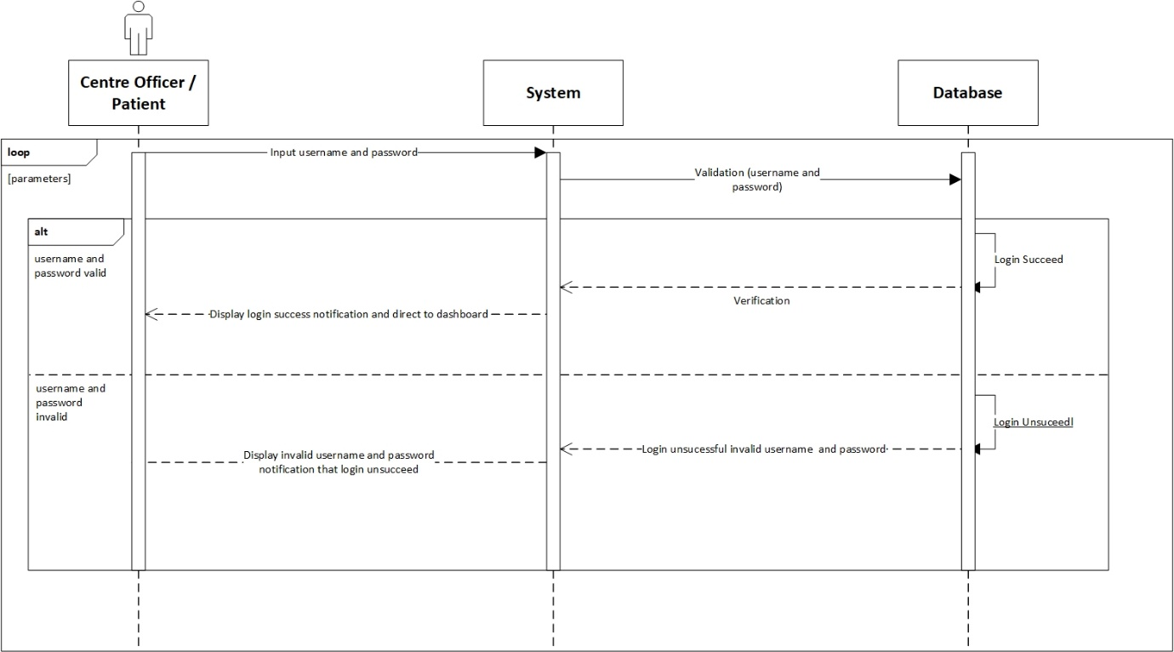

**Prepared by: Ida Bagus Gede Awidya Andika**

|  |  |
| --- | --- |
| **Cross References** | **Login** |
| Operation | Login with username and password. |
| Responsible | To access the main menu page. |
| Pre-conditions | * A valid username is required * A valid password is required |
| Post-conditions | * Username is matched * Password is matched * Display dashboard |

* 1. View Test Kit

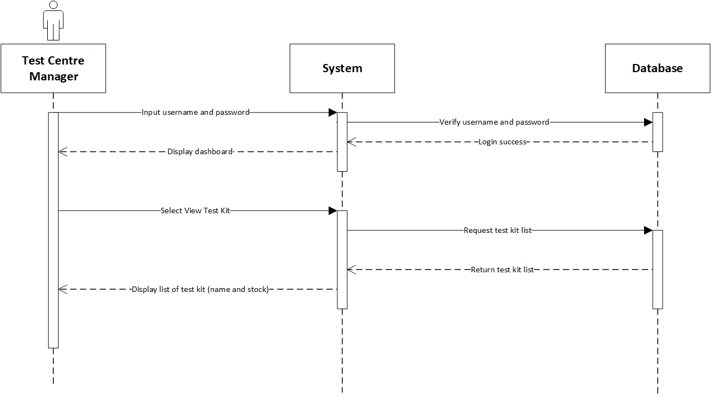

**Prepared by: Ida Bagus Gede Awidya Andika**

|  |  |
| --- | --- |
| **Cross References** | **View Test Kit** |
| Operation | Login with username and password. |
| Responsible | To access the view test kit menu. |
| Pre-conditions | * A valid username is required * A valid password is required |
| Post-conditions | * Username is matched * Password is matched * Display dashboard |
| **Cross References** | **View Test Kit** |
| Operation | View data test kit from test kit menu. |
| Responsible | To view all list data test kit. |
| Pre-conditions | The test kit object must be available. |
| Post-conditions | The list of test kit will be display name and available stock from test kit. |

* 1. Manage Test Kit

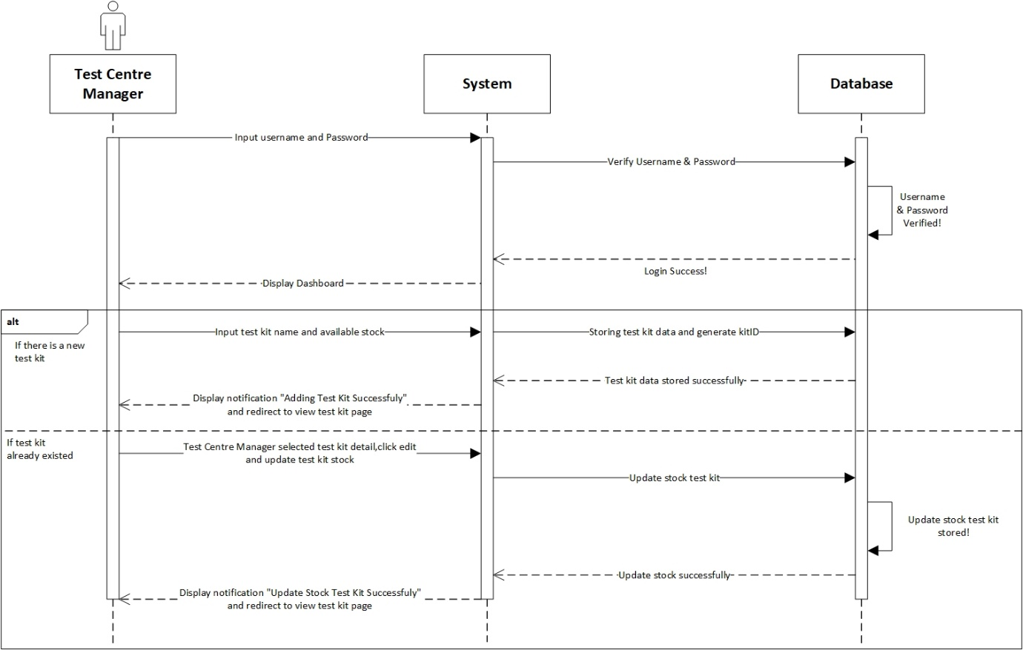

**Prepared by: Ida Bagus Gede Awidya Andika**

|  |  |
| --- | --- |
| **Cross References** | **Manage Test Kit** |
| Operation | Login with username and password. |
| Responsible | To access the manage test kit menu. |
| Pre-conditions | * A valid username is required * A valid password is required |
| Post-conditions | * Username is matched * Password is matched * Display dashboard |
| **Cross References** | **Manage Test Kit** |
| Operation | Manage test kit. |
| Responsible | To add new test kit with name and available stock. |
| Pre-conditions | Object testName and availableStock must be available. |
| Post-conditions | New test kit was successfully added to the system. |
| **Cross References** | **Manage Test Kit** |
| Operation | Manage test kit. |
| Responsible | To update available stock from test kit. |
| Pre-conditions | Detail availableStock must be available. |
| Post-conditions | Update stock test kit was successfully. |

* 1. View Test Centre

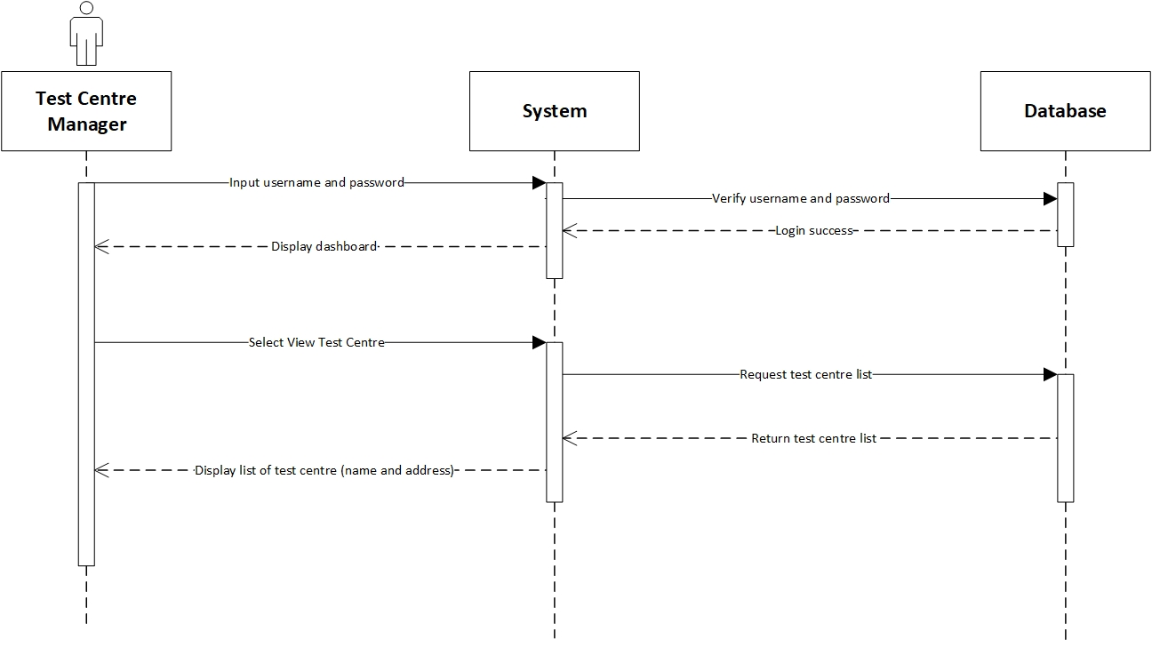

**Prepared by: Ida Bagus Gede Awidya Andika**

|  |  |
| --- | --- |
| **Cross References** | **View Test Centre** |
| Operation | Login with username and password. |
| Responsible | To access the view test centre menu. |
| Pre-conditions | * A valid username is required * A valid password is required |
| Post-conditions | * Username is matched * Password is matched * Display dashboard |
| **Cross References** | **View Test Centre** |
| Operation | View data test centre from test centre menu. |
| Responsible | To view all list data test centre. |
| Pre-conditions | The test centre object must be available. |
| Post-conditions | The list of test centre will be display name, address, postal code, phone and city from test centre. |

* 1. Register Test Centre

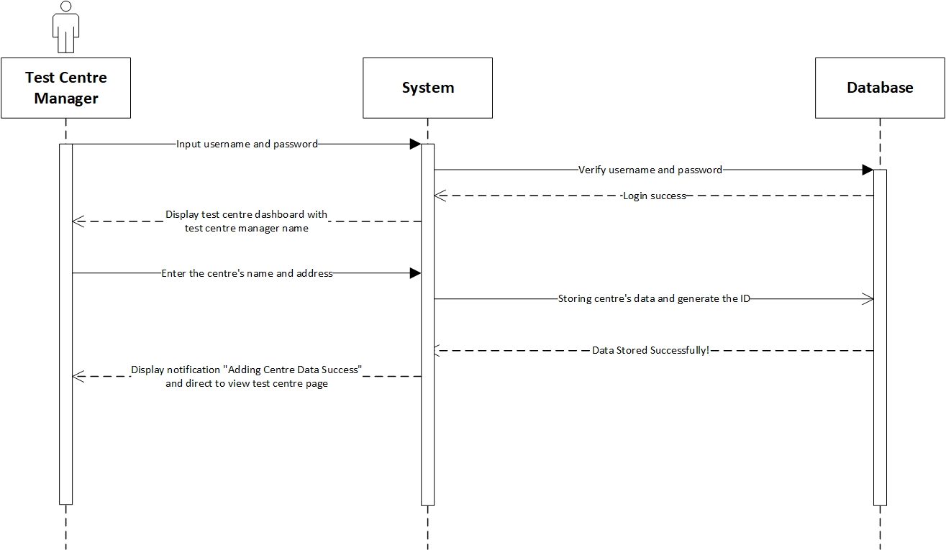

**Prepared by: Ida Bagus Gede Awidya Andika**

|  |  |
| --- | --- |
| **Cross References** | **Register Test Centre** |
| Operation | Login with username and password. |
| Responsible | To access the register test centre menu. |
| Pre-conditions | * A valid username is required * A valid password is required |
| Post-conditions | * Username is matched * Password is matched * Display dashboard |
| **Cross References** | **Register Test Centre** |
| Operation | Register test centre with name, address, postal code, phone and city from test centre. |
| Responsible | To register new test centre able to access the system. |
| Pre-conditions | Following data below that should be available:   * Name test centre * Address * Postal code * Phone * City |
| Post-conditions | Register test centre was successfully added to the system and will be display to test centre dashboard. |

* 1. View Test Centre Officer

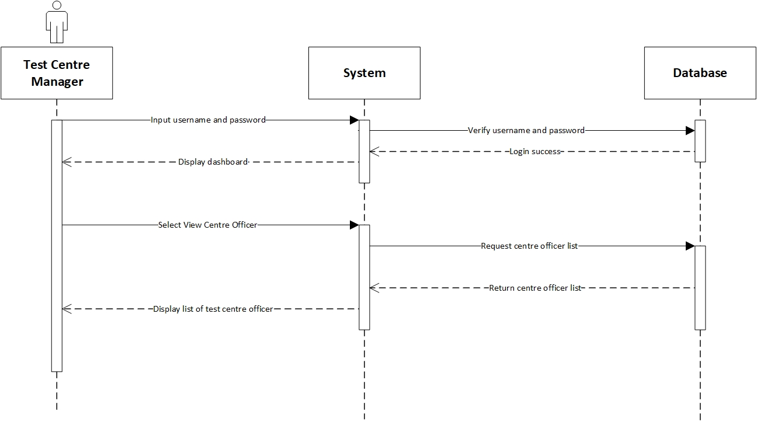

**Prepared by: Ida Bagus Gede Awidya Andika**

|  |  |
| --- | --- |
| **Cross References** | **View Test Centre Officer** |
| Operation | Login with username and password. |
| Responsible | To access the view test centre officer menu. |
| Pre-conditions | * A valid username is required * A valid password is required |
| Post-conditions | * Username is matched * Password is matched * Display dashboard |
| **Cross References** | **View Test Centre Officer** |
| Operation | View data test centre officer from test centre officer menu. |
| Responsible | To view all list data test centre. |
| Pre-conditions | The test centre officer object must be available. |
| Post-conditions | The list of test centre officer will be display name, email, phone, gender, address, age, birth date and position from test centre. |

* 1. Record Tester

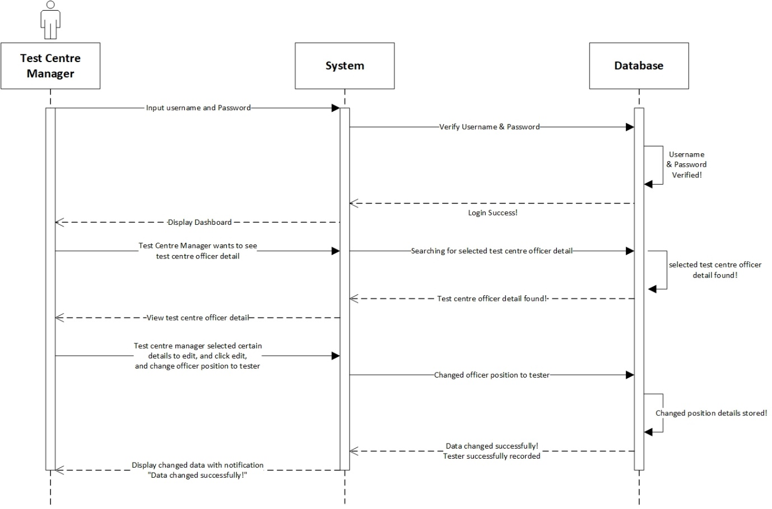

**Prepared by: I Made Siva Aditya Surya**

|  |  |
| --- | --- |
| **Cross References** | **Record Tester** |
| Operation | Login with username and password. |
| Responsible | To access the record tester menu. |
| Pre-conditions | * A valid username is required * A valid password is required |
| Post-conditions | * Username is matched * Password is matched * Display dashboard |
| **Cross References** | **Record Tester** |
| Operation | Update position test centre officer. |
| Responsible | To update the position test centre officer to tester. |
| Pre-conditions | The test centre officer must be available. |
| Post-conditions | Update position tester was successfully changed to the system. |

* 1. Record Officer

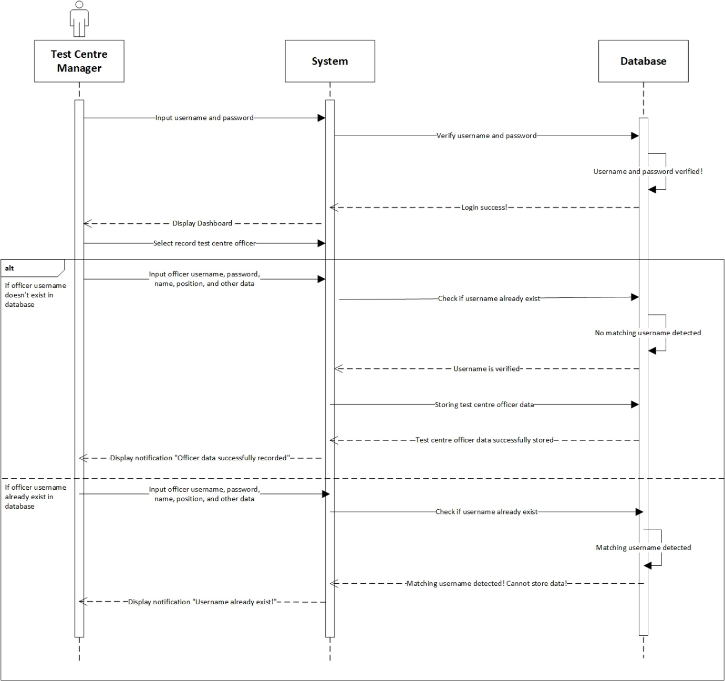

**Prepared by: I Made Siva Aditya Surya**

|  |  |
| --- | --- |
| **Cross References** | **Record Officer** |
| Operation | Login with username and password. |
| Responsible | To access the record officer menu. |
| Pre-conditions | * A valid username is required * A valid password is required |
| Post-conditions | * Username is matched * Password is matched * Display dashboard |
| **Cross References** | **Record Officer** |
| Operation | Record test centre officer with username, password, name, email, phone, gender, address, age and birth date. |
| Responsible | To be recorded in system and able to access the test centre dashboard. |
| Pre-conditions | Following data below that should be available:   * Username * Password * Name * Email * Phone * Gender * Address * Age * Birth Date |
| Post-conditions | * Username has not been existed. * Recorded in system. * Display dashboard. |
| **Cross References** | **Record Officer** |
| Operation | Record test centre officer with username, password, name, email, phone, gender, address, age and birth date. |
| Responsible | To be recorded in system and able to access the test centre dashboard. |
| Pre-conditions | Following data below that should be available:   * Username * Password * Name * Email * Phone * Gender * Address * Age * Birth Date |
| Post-conditions | * Username has been existed. * Test Centre Manager must be re-enter new username. * Display dashboard. |

* 1. Record New Test

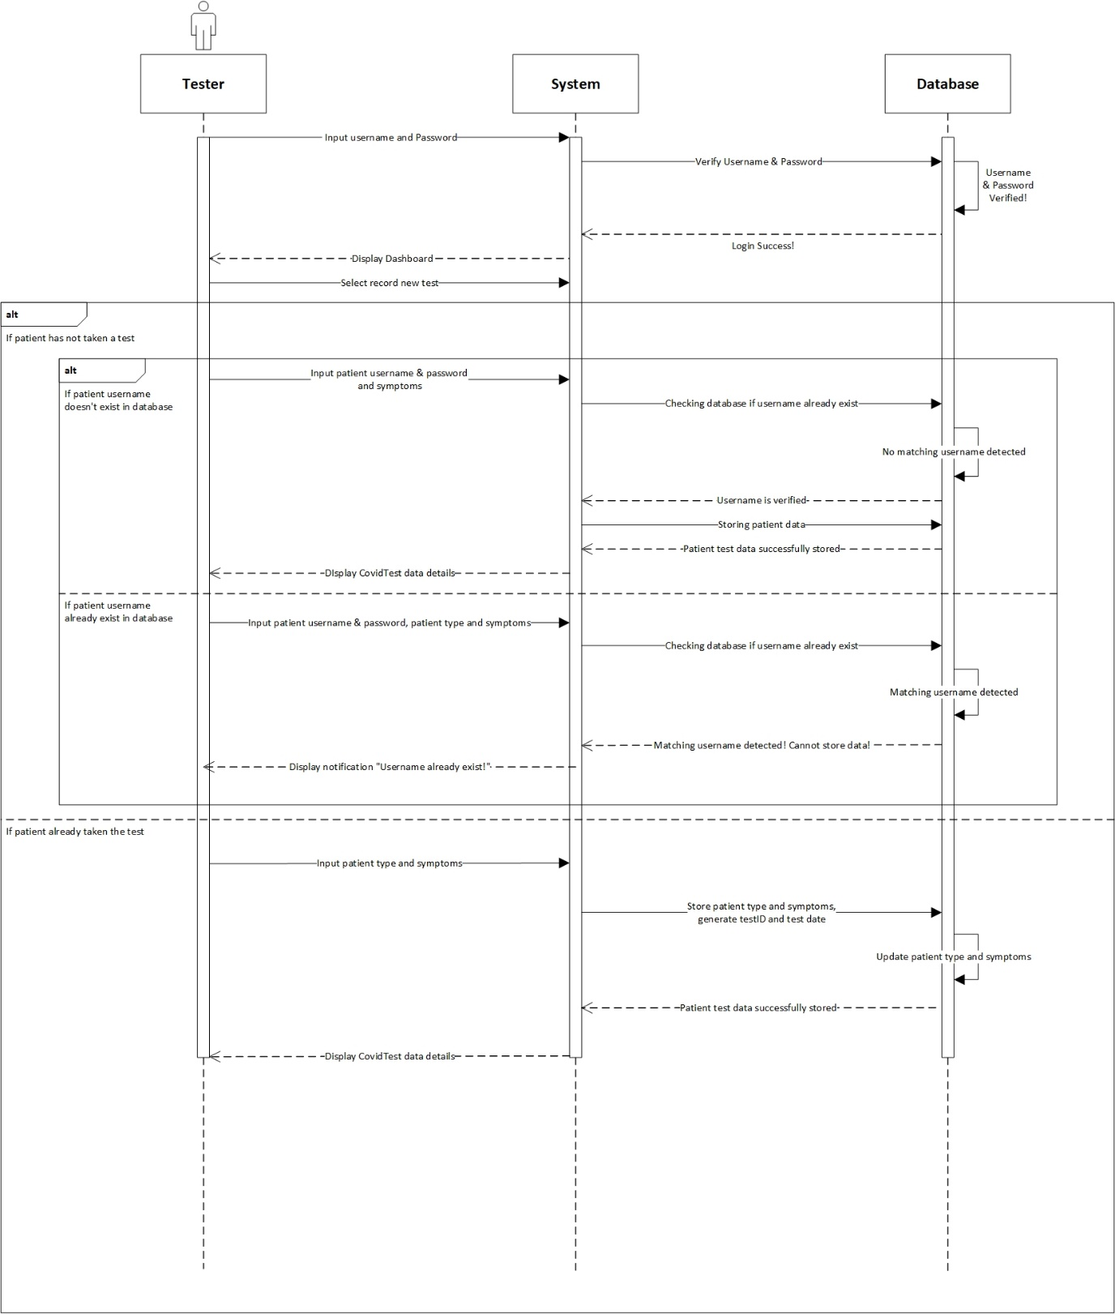

**Prepared by: I Made Siva Aditya Surya**

|  |  |
| --- | --- |
| **Cross References** | **Record New Test** |
| Operation | Login with username and password. |
| Responsible | To access the record new test menu. |
| Pre-conditions | * A valid username is required * A valid password is required |
| Post-conditions | * Username is matched * Password is matched * Display dashboard |
| **Cross References** | **Record New Test** |
| Operation | Record tester with username, password and symptoms. |
| Responsible | To be recorded in system that if patient has been not taken the test. |
| Pre-conditions | Following data below that should be available:   * Username * Password * Symptoms |
| Post-conditions | * Username, password and symptoms has not been existed. * Successfully added to system. * Display dashboard. |
| **Cross References** | **Record New Test** |
| Operation | Record tester with username, password, patient type and symptoms. |
| Responsible | To be recorded in system that if patient has been not taken the test but already register an account. |
| Pre-conditions | Following data below that should be available:   * Username * Password * Patient type * Symptoms |
| Post-conditions | * Username, password, patient type and symptoms are matched. * Display dashboard. |
| **Cross References** | **Record New Test** |
| Operation | Record tester with patient type and symptoms. |
| Responsible | To be recorded in system that if patient has been taken the test. |
| Pre-conditions | Following data below that should be available:   * Patient type * Symptoms |
| Post-conditions | The list of the patient details will be display. |

* 1. Update Test Result

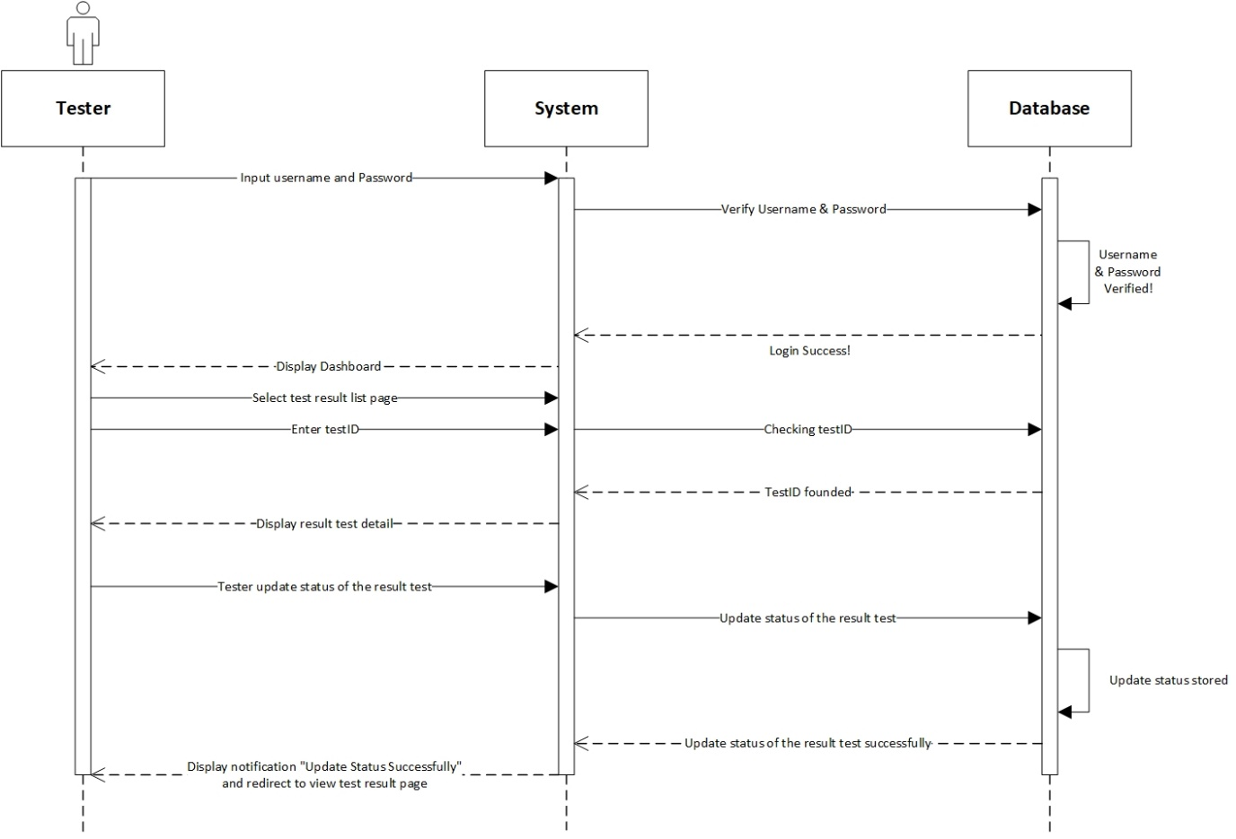

**Prepared by: I Made Siva Aditya Surya**

|  |  |
| --- | --- |
| **Cross References** | **Update Test Result** |
| Operation | Login with username and password. |
| Responsible | To access the update test result menu. |
| Pre-conditions | * A valid username is required * A valid password is required |
| Post-conditions | * Username is matched * Password is matched * Display dashboard |
| **Cross References** | **Update Test Result** |
| Operation | Update test result of the tester. |
| Responsible | To update the result test status of the tester. |
| Pre-conditions | The result test and testID must be available. |
| Post-conditions | Update result test status tester was successfully changed to the system. |

* 1. Generate Test Report

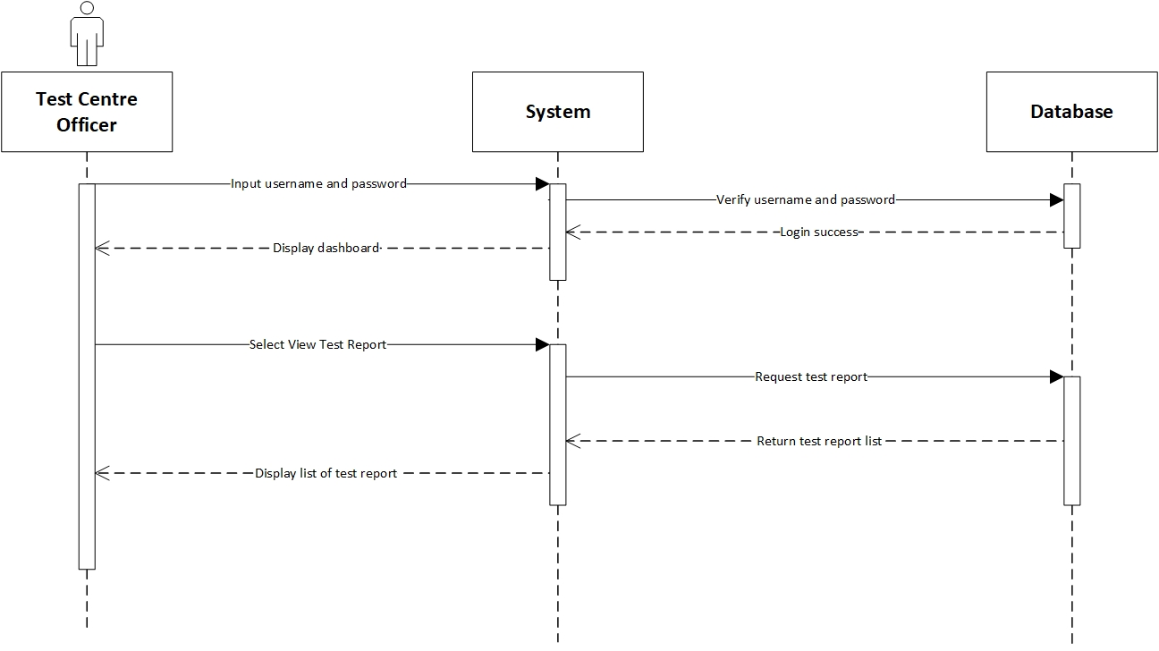

**Prepared by: I Made Siva Aditya Surya**

|  |  |
| --- | --- |
| **Cross References** | **Generate Test Report** |
| Operation | Login with username and password. |
| Responsible | To access the generate test report menu. |
| Pre-conditions | * A valid username is required * A valid password is required |
| Post-conditions | * Username is matched * Password is matched * Display dashboard |
| **Cross References** | **Generate Test Report** |
| Operation | View data test report from test centre officer menu. |
| Responsible | To view all list data test report. |
| Pre-conditions | The test centre officer object and test report must be available. |
| Post-conditions | The list of test report will be display test id, test date, result date and status. |

* 1. View Testing History

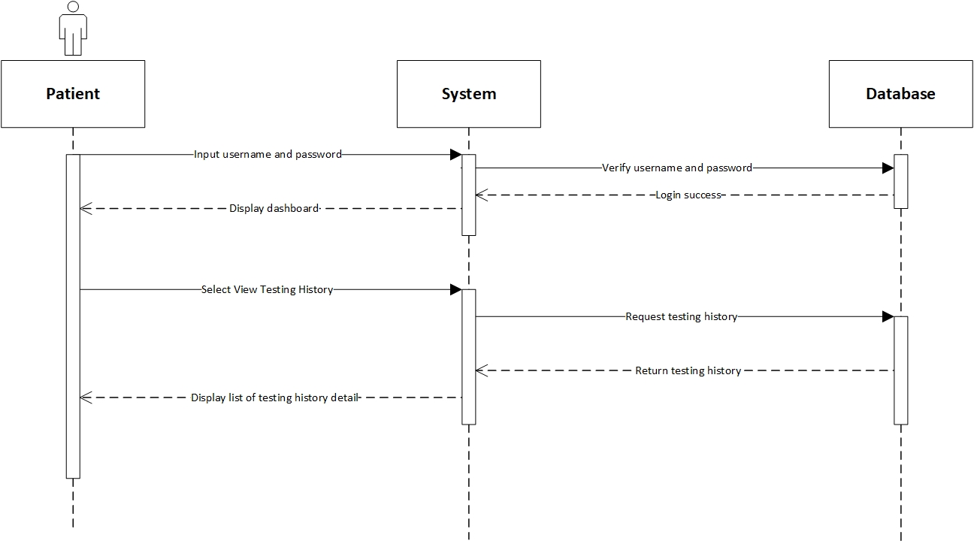

**Prepared by: I Made Siva Aditya Surya**

|  |  |
| --- | --- |
| **Cross References** | **View Testing History** |
| Operation | Login with username and password. |
| Responsible | To access the view testing history menu. |
| Pre-conditions | * A valid username is required * A valid password is required |
| Post-conditions | * Username is matched * Password is matched * Display dashboard |
| **Cross References** | **View Testing History** |
| Operation | View testing history from patient menu. |
| Responsible | To view all list data testing report. |
| Pre-conditions | The patient object and testing report must be available. |
| Post-conditions | The list of testing history will be display test id, test date, result date and status. |

* 1. Log Out

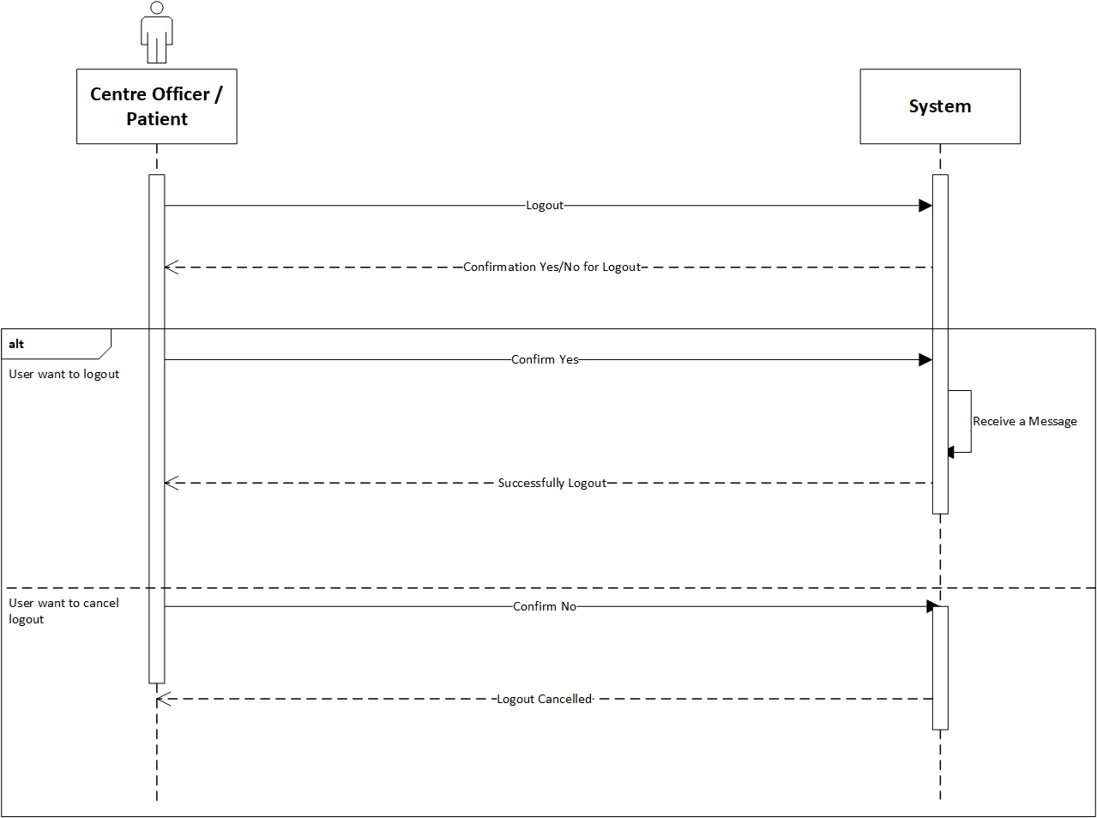

**Prepared by: Ida Bagus Gede Awidya Andika**

|  |  |
| --- | --- |
| **Cross References** | **Logout** |
| Operation | Centre officer or patient want to log out |
| Responsible | To log out or exit from the system |
| Pre-conditions | The centre officer or patient accepts if they want to log out |
| Post-conditions | Success logout from the system. |
| **Cross References** | **Logout** |
| Operation | Cancel to log out |
| Responsible | To cancel log out or exit from the system |
| Pre-conditions | The centre officer or patient want cancel the log out by clicking the “No” option in the system. |
| Post-conditions | Cancel logout from the system |